
ITX660B(R100)

Product Feature:
- Intel 12th generation Alder Lake-S series/13th generation Raptor Lake-s series, LGA1700, TDP 65W; H610/B660/H670
- 2*DDR5 SO-DIMM, up to 64GB
- 2*RTL8111H Network, HDMI+DP+VGA
- M-Key 2280, E-Key, PCIe_X16
- Power Supply: ATX 24+4 Pin Size:170x170 mm

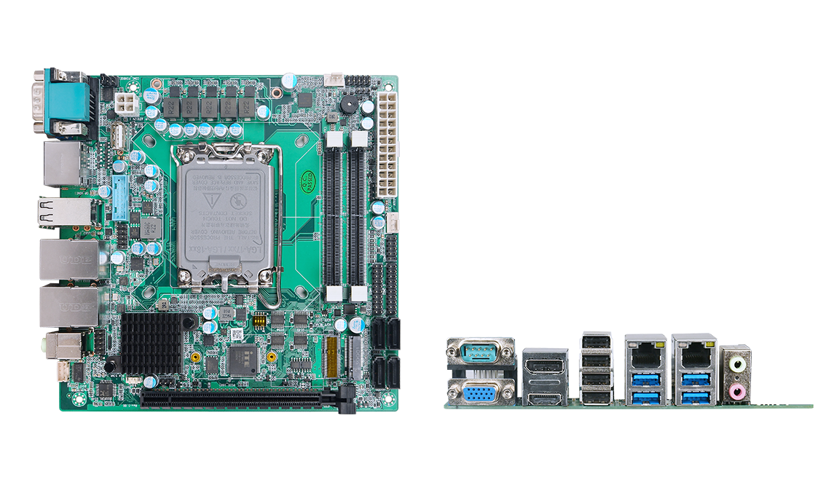

Product Specification
Processor System | Intel 12th Generation Alder Lake-Series/13th Generation Raptor Lake-Series, LGA1700, TDP 65W
Processor System | EFI BIOS
Memory | 2*DDR5 SO-DIMM 64GB max (12th Gen, 4800MHz max; 13th Gen, 5600MHz max)
Storage | 1*M.2 M-Key 2280 (NVMe PCIe3.0_x4 protocol) storage interface
Storage | 4*SATA3.0 interface (no RAID in H610; RAID 0/1/5/10 in B660/H670)
Display | 1*HDMI2.0 interface, support 4K@60Hz
Display | 1*DP1.4 interface, support 4K@60Hz
Display | 1*VGA
Board Side I/O Interface | DB9 COM1 (RS232, can jump to select 5V/12V output), VGA, HDMI, DP
Board Side I/O Interface | 4*USB2.0
Board Side I/O Interface | 2*(LAN + 2*USB3.2), 2-hole audio input and output (Line out, Mic in)
Expansion Interfaces/Features | TPM2.0 optional, not available by default
Expansion Interfaces/Features | 1*PCIe_X16 (PCIe4.0_16x protocol)
Expansion Interfaces/Features | 1*M.2 E-Key (PCIe3.0+USB2.0 protocol, support WIFI/BT module)
Expansion Interfaces/Features | 5*COM pins, 2x5Pin, 2.54m spacing; COM2 can be jumped to select RS422/485, COM3/4/5/6 for RS232
Expansion Interfaces/Features | 1 group of 2 USB3.0 pins, spacing 2.0mm (H610 bridge, there is no such function; B660 and above bridge only)
Expansion Interfaces/Features | 1 set of 2 USB2.0 pins, spacing 2.54mm; 1 built-in vertical USB2.0
Expansion Interfaces/Features | 1*4Pin PWM CPU fan, 1*4Pin system fan
Power Supply | ATX 24+4 Pin, 200W or more (depending on the actual use environment)
Operating Environment | Operating Temperature: -20℃ ~ +60℃; Operating Humidity: 5% ~ 90
Operating Environment | Storage temperature: -40℃ ~ +85℃; Storage humidity: 5% ~ 90%
Operating System Support | Windows 10, Windows 11, Linux
Dimensions | 170x170 mm
Weight | Approx. 400g
ITX660B(R100)
Product Size unit：mm

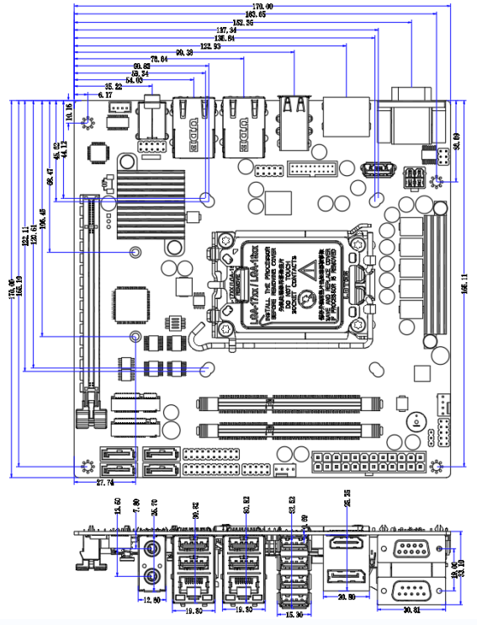

Order Information
Module | Optional items | Description of options
ITX660B | External TPM2.0 | External TPM2.0 optional
ITX660B | Serial port optional | No serial port;  COM2 is RS422/RS485 optional;  COM1/3/4/5/6 for RS232
ITX660B | Chipset | H610/B660/H670 optional

